

American International University- Bangladesh

CSC 3222: Web Technologies

CO1.1 and CO2.1 Evaluation

Project Report

Fall 19-20

Project Title: **Hospital Management System**

Section: H

|  |  |
| --- | --- |
| Student Name | Student Id |
| ZONEZO, ZAFIR ZAWAD | 17-35281-2 |
| AYSHI, AISHWARYA DEBNATH | 18-36042-1 |
| RAHAMAN, ASHRAFUR | 17-35211-2 |
| SHARIF, LOKMAN HOSSAIN | 19-39579-1 |

Introduction:

This project, Hospital management system is a web-based application that provides a health care environment for patient registration and appointment scheduling are time-consuming and somehow troublesome. This web-based application or system will propagate to manage the appointment-booking process for the medical organizations, regardless of the types of service they schedule. The practices will have to sign up on the online appointments portal themselves and can view the appointment made by users. It will help the users, to book and maintain their appointments by storing records regarding health issues and blood donation using the system.

Background Study

[*https://www.e-hospitalservices.net/*](https://www.e-hospitalservices.net/) website was taken which helps us create a similar system.

Requirement Analysis:

1. User Category:

There are 4 types of Users here. They are:

* Admin
* Doctor
* Patient
* Donor

1. Feature List:

In this project the “Admin” has the following features:

1. Can see the personal details.

2. Can edit personal information.

3. Can Search profiles

4. Can register to the system

5. Can update his profile information

6. Can add & delete doctor

7. Also can add & delete patient

8. Also can add & delete donor

9. Access on information

10. Can verify profiles

11. Manage all user profiles

12. Can manipulate booking information (edit-delete-view etc.)

13. Manage membership schedule

14. Food management for patient’s diet and hospital cafeteria

15. Hospital pharmacy monitoring information module

16. Ward managements, provide various types of planning and tracking etc.

17. Communicate with users

In this project the “Doctor” has the following features:

1. Can see the personal details.

2. Can Create their own profile.

3. Can Update their own profile.

4. Can Remove their own profile.

5. Can Delete their own profile.

6. Can see patient’s profile.

7. Can check list of patients.

8. Can accept the appointment request.

9. Can decline the appointment request.

10. Can Create their own time schedule.

11. Can Remove their own time schedule.

12. Can Update their own time schedule.

13. Can Delete their own time schedule.

14. Can see the list of the donors.

15. Can see the drug list, pharmacy information.

16. Can see patient’s admittance information.

17. Chat option.

In this project the “Patient” has the following features:

1. Can see the personal details

2. Can Create their own profile

3. Can remove their own profile

4. Can Update their own profile

5. Can search for doctor services basing his or her requirement

6. Can send appointment request

7. Patient can see their admittance information

8. Patient can see their billing, insurance and credit tracking

9. Patient can see Pharmacy information, booking and purchase

10. patient can buy a particular drug immediately or order it in advance

11. Patient notification. Notifies patients about their appointments, medication times, discharge recommendations, etc.

12. Can see the list of donors

13. Can send request to donor according to their requirement

14. Emergency care module. Allows speeding up the process of registration and admission during pre-hospital treatment, such as in emergency rooms.

15. Can see doctor profile

In this project the “Donor” has the following features:

1. Can Create their own profile.

2. Can Register their own profile.

3. Can Update their own profile.

4. Can Remove their own profile.

5. Can Delete their own profile.

6. Can see the personal details

7. Can accept the donation request

8. Can decline the donation request

9. Donor can see hospital location

10. Donor can see their donation history

11. Donor can add report (blood test report)

12. Donor can communicate hospital/people.

13. Donor can console with doctor

14. Special discounts for the treatment of donors.

15. Can check list of blood request.

Design:

Draw an entity diagram of your project here.

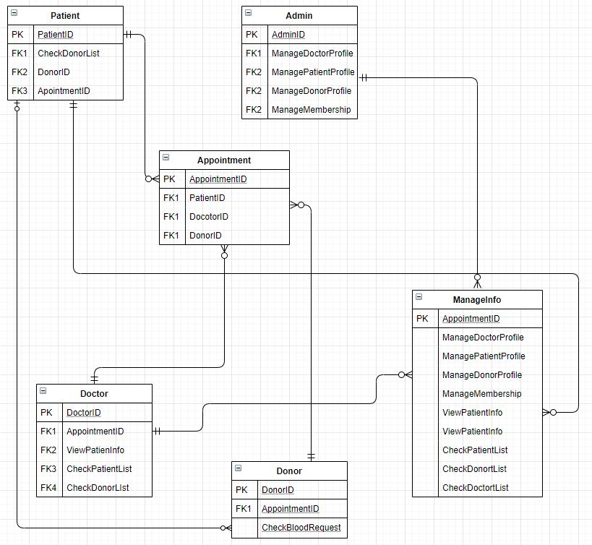

Figure: Entity Diagram of the Hospital Management System

Tools Used:

To develop this project, we have used the following:

• Notepad++ **/** Subline Text

• Draw.io

• Snipping Tool

• Google Chrome

• XAMPP

System Images against the Specification:

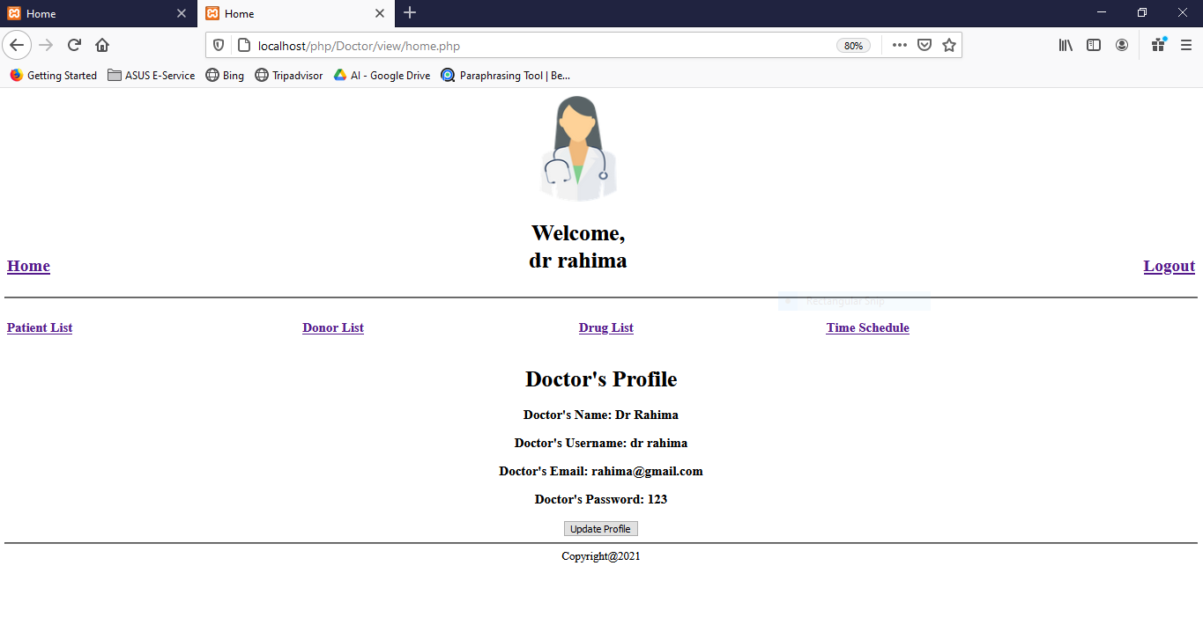 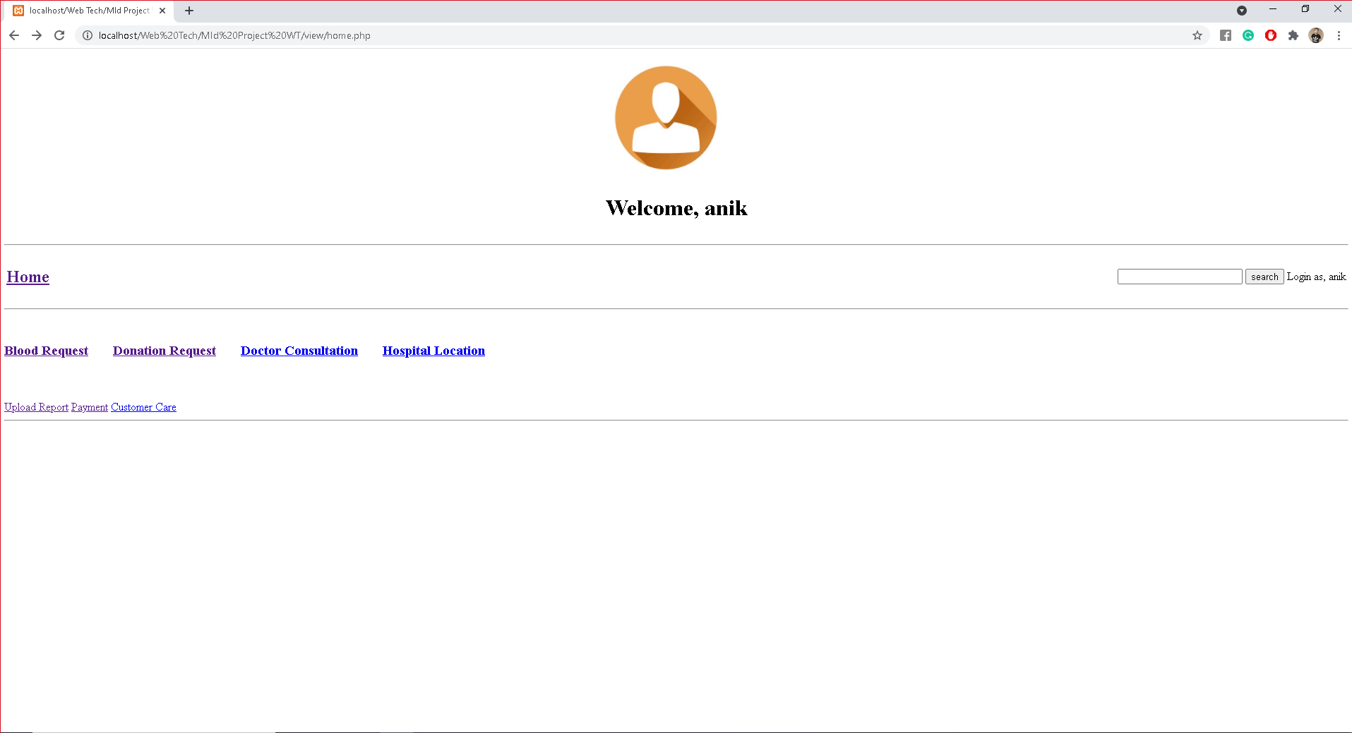

Impact of this Project:

**Impact:**

System will help the user to reduce unnecessary hustle for booking and maintaining the appointments. Also, it will reduce extra reception staff, a significant reduction in labor and will provide accurate information regarding doctor, donor, and available stored blood. Furthermore, it helps user in time saving and avoiding the need to negotiate with the receptionist for a convenient appointment time. This technology can transform the current daunting appointment process and enable them to run more efficiently, effectively and profitably.

**Limitations and Possible Future Improvements:**

System may have some limitations like it always need internet connections, it may be unfriendly and complicated websites. For possible future improvements system should be modified so that it can be ready for an influx. Avoid booking system that don't brings the new quality customers. System should Confirm appointments with text or email reminders. Automate responses to routine questions and offline remainders. System should be updated after a certain amount of time so that users can be updated with the current changes.

*[Note: Make sure that your report is maximum 10 pages (including cover page). Print (Colored) the report and submit it with spiral bind.]*

|  |  |  |  |  |  |
| --- | --- | --- | --- | --- | --- |
| CO1.1 and CO2.1 Evaluation: Project Report Evaluation | | | | | |
| Project Proposal  (5) | Background  Study  (5) | Requirement Analysis  (5) | Entity  Diagram  (5) | System Images  against the  Specification (5) | Total (25) |
|  |  |  |  |  |  |
|  | | | | | |